Part 1: OpenAI API Key

Part 1: OpenAI API Key

Hey Learner,
Hope you’re doing well!
As part of your Applied Agentic AI course, you will be working with the Open AI API key. You should receive an API key in your email registered on Interview Kickstart's Uplevel after receiving this communication.
**Please refrain from consuming your API key credits unnecessarily on other projects or work, as we have limited access to these credits during the course. We need these credits for you to use them for the projects completed in the live class and for solving the assignments in this course. **
For now, simply check whether the key is working by following these steps. You can do this small step before the class, so that you are all set

OpenAI API Key and Testing the Key {NEEDED FOR CLASS 1}
You will receive a dedicated OpenAI API Key from Interview Kickstart at your registered email id. That key is going to be used throughout the program, so make sure you save it.
✅ Before the session, make sure your API Key is working.
Use the link below to test your API Key.
→ ⁠https://trevorfox.com/api-key-tester/openai
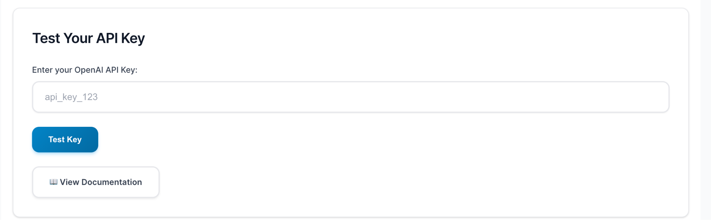

Note: We have shared the OpenAI API key via email. Please check your inbox or spam folder to find it. If you’re unable to locate it, please reply to this email. The API key provides access to the "gpt-4o" model for use during the Week 1 class.

Part 2: Google Colab Setup

Part 2: Google Colab Setup

Google Colab is a cloud-based Jupyter Notebook environment that lets you run Python code without installing anything locally.

Step 1: Open Google Colab
- Go to: https://colab.research.google.com
- Sign in using your Google account

Step 2: Create a New Notebook
- Click New Notebook
- A Python notebook will open automatically
- Rename it (optional) from the top-left (e.g., Agentic_AI_Demo.ipynb)

Step 3: Check Runtime
- Click Runtime → Change runtime type
- Ensure:
  - Runtime type: Python 3
  - Hardware accelerator: None (GPU not required unless specified)
- Click Save

